Customer churn Prediction

Harisivamoorthi. P.G

**Table of Contents**

**1.Problem Understanding** 3

**a)** **Defining problem statement:** 3

**Data Dictionary:** 3

**b)** **Need of the study/project:** 4

**C) Understanding business/social opportunity:** 4

**2)Understanding ofData** 4

**a)** **Understanding how data was collected in terms of time, frequency and methodology:** 4

**b)** **Visual inspection of data (rows, columns, descriptive details):** 4

**c)** **Understanding of attributes (variable info, renaming if required)** 6

**3. Exploratory Data Analysis:** 7

**3.A Univariate analysis (distribution and spread for every continuous attribute, distribution of data in categories for categorical ones):** 7

**3.A (1) For Continuous Features:** 7

**Inferences-Univariate:** 13

**3.B Bivariate analysis (relationship between different variables, correlations):** 14

**Inference: Bi-variate:** 18

**3.B (1) Multi-variate Analysis:** 19

**Inference-Multivariate:** 22

**3.B (2) Correlation among variables:** 22

**Inference from correlation:** 23

**3. (c) Any other business insights:** 24

**4). Model building and interpretation.** 25

**4 (a). Build various models (You can choose to build models for either or all of descriptive, predictive or prescriptive purposes)** 25

**4. (B). Interpretation of the most optimum model and its implication on the business** 26

**5.Recommendations:** 29

**LIST OF TABLES**

Table 1:Total number of rows & cols 5

Table 2: Descriptive stats 5

Table 3: Variable info (data types) 6

Table 4:Comparison Across Various Models 26

**LIST OF FIGURES**

Figure 1:Histogram: Numeric feature data distribution 7

Figure 2:Boxplot: Numeric feature data distribution 9

Figure 3:countplot: Churn 10

Figure 4:countplot: Payment method 10

Figure 5:countplot: Gender ratio 11

Figure 6: count-plot: Account segment (Plans) 12

Figure 7:Count plot: Marital status 12

Figure 8:count plot: Login device 13

Figure 9: Bar plot: Revenue per month by gender 14

Figure 10: Bar plot: Churning based on service score 15

Figure 11: Customer care contacted last year based on Account segment(plans) 15

Figure 12: Bar plot: Complaint made by gender 16

Figure 13: Churning by city tier 17

Figure 14: Pairplot 18

Figure 15:Gender wise complaints registered based on their marital status 19

Figure 16: Churning by marital status with revenue growth yoy 20

Figure 17: Service score by account segment with their churning pattern 21

Figure 18:Complaint’s registered by gender ratio based on churning 21

Figure 19: Correlation map 23

Figure 20:Shape of Training and Test data set 25

Figure 21:Customer segments 30

# **1.Problem Understanding**

## **Defining problem statement:**

Business Objective an E Commerce company or DTH (you can choose either of these two domains) provider is facing a lot of competition in the current market and it has become a challenge to retain the existing customers in the current situation. Hence, the company wants to develop a model through which they can do churn prediction of the accounts and provide segmented offers to the potential churners. In this company, account churn is a major thing because 1 account can have multiple customers. hence by losing one account the company might be losing more than one customer. You have been assigned to develop a churn prediction model for this company and provide business recommendations on the campaign. Your campaign suggestion should be unique and be very clear on the campaign offer because your recommendation will go through the revenue assurance team. If they find that you are giving a lot of free (or subsidized) stuff thereby making a loss to the company; they are not going to approve your recommendation

. Hence be very careful while providing campaign recommendation

### **Data Dictionary:**



## **Need of the study/project:**

* We will choose this as DTH domain customer churn.
* The need for the customer churn prediction project is to help the company identify customers who are at risk of churning and to take steps to prevent them from doing so. Churn is a costly problem for businesses, as it can lead to lost revenue, increased marketing costs, and a decline in customer satisfaction.
* By identifying and preventing churn, businesses can improve their bottom line and provide a better experience for their customers.

# **C) Understanding business/social opportunity:**

* The customer churn prediction project will use data analysis to identify customers who are at risk of churning. The data analysis will look at factors such as customer spending, customer behavior, and customer satisfaction.
* Once the customers who are at risk of churning have been identified, the company can take steps to prevent them from leaving, such as offering them discounts, upgrades, or other incentives.
* The customer churn prediction project is a valuable tool that can help businesses improve their customer retention rates and reduce their costs.
* The company should carefully consider the cost of each campaign suggestion before implementing it.
* The company should also make sure that the campaign is targeted to the specific customers who are at risk of churning.
* By taking these steps, the company can maximize the effectiveness of its customer churn prevention efforts.

# **2)Understanding ofData**

## **Understanding how data was collected in terms of time, frequency and methodology:**

* There is no indication of the time line of this data in the problem description or meta data.
* Based on the data set, we may conclude that this data was acquired during the previous 6 months.

## **Visual inspection of data (rows, columns, descriptive details):**

Table :Total number of rows & cols



* In this dataset, has 11260 rows and 19 columns.
* We can drop the columns later if may not need for the further analysis.

Table : Descriptive stats

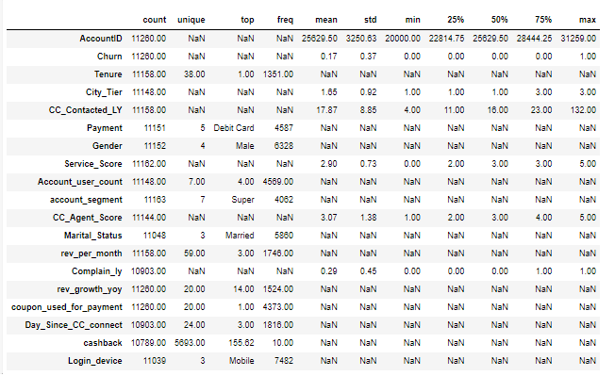

* Based on the summary of descriptive statistics mentioned above, we may draw the following conclusion.
* According to the churn feature, 75% of customers are non-churners. This implies that a significant majority of customers are staying with the service or product, while a smaller percentage may be leaving or discontinuing their subscription or usage of the service.
* And the average number of times a consumer contacts customer service is 17. This indicates that, on average, customers reach out to customer service for assistance or inquiries approximately 17 times. It suggests that there may be a moderate level of interaction between customers and customer service representatives.
* The majority of customers are willing to use their debit cards to pay. This suggests that a significant portion of customers prefer using debit cards as their primary payment method.
* In a similar vein, the gender ratio shows that men make up the bigger proportion.
* The customer service rating scale goes from 0 to 5, with 50% of customers giving it a 3 out of 5. This suggests that, on average, customers have a neutral opinion or satisfaction level with the customer service provided.
* We could see the account segmentation and customer spending-based segmentation. 'Super' plans apply to the majority of customers. This may be the cost-effective plan for its six-month validity. This indicates that a significant portion of customers are subscribed to the 'Super' plans, which likely offer cost-effectiveness and a validity period of six months. It implies that the majority of customers find value in these plans and opt for them over other available options.
* Here we can drop the [‘Account_ID’] feature from the data set, we don’t use much for the analysis. This feature can be used to find the duplicate values, in this data set we don’t have any duplicate values present.

## **Understanding of attributes (variable info, renaming if required)**

Table : Variable info (data types)

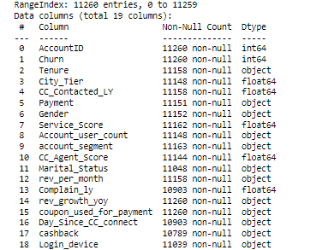

* Since we already know that this data set has total of 11260 rows and 19 columns.
* From this above table, we can able to see that some of the columns has missing values in it, we can treat it further.
* Renaming of features doesn’t required here, so we can proceed further with our analysis.

# **3. Exploratory Data Analysis:**

## **3.A Univariate analysis (distribution and spread for every continuous attribute, distribution of data in categories for categorical ones):**

### **3.A (1) For Continuous Features:**

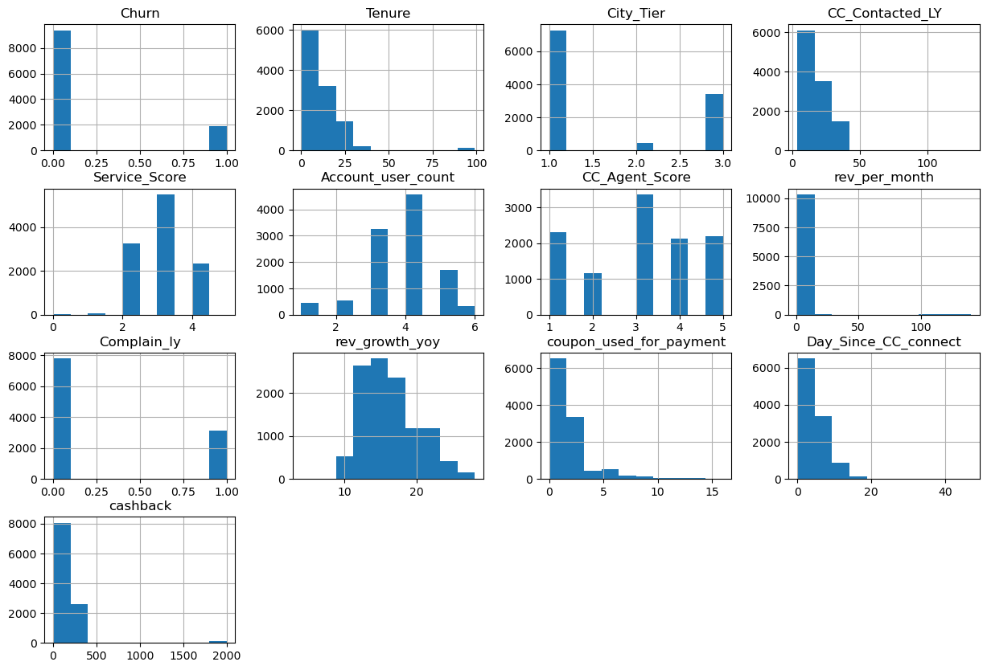

Figure :Histogram: Numeric feature data distribution

* From the above histogram, we can able to understand how the data is distributed.
* Here we have visualized the hist plots for the numeric feature.
* Dependent variable (churn) has 2 values, 0 represents non-churners and 1 represent churners in which majority of the data is fall under non-churners.
* If we take a look at ‘Tenure’, it represents the tenure of the account. It was ranging from 0 to 100 and majority of them has the tenure period of 1. Because, initially the DTH company may offer 1 month of trial and free period.
* Hence most of the users, preferred to use 1month trial. If user has attracted with their service and content then they will not be in churn.
* And Interestingly most of the primary customers are from the tier 1 city secondly from the tier 3 city. By which can assume tier I city customer mostly likely to watch contents in HD so they mostly prefer DTH.
* But in tier 3 city, there might be different scenario. They don’t have much accessibility on local cable TV operators. Hence, they preferred to use DTH.
* And reason for fewer customer in tier 2 city might be, they have easy access on local cable TV operators.
* When we look at the service provided by DTH company based on their customer rating, majority of the customers have been rated 3. This means customers are satisfied with company services.
* And we could also notice that no. of customers tagged to particular account, nearly 4K customers has 4 user account has been tagged to one single account.
* We could see that similar pattern in ‘CC_Agent_score’.in which it has around 3500 of the customers have ratted 3 for customer care Service provided by the company.
* When we look at the revenue generation we could see that on Average of 6$ revenue has been generated by nearly 9K customers per month.
* And we could also notice that very fewer number of complaints was registered by the customer’s account for the last 1 year.
* Revenue generated by year on year indicating that there is increase in the revenue by each year and it more or less fall in normal distribution.
* We can find another interesting fact from this analysis, most of the customers doesn’t use any coupon for the payments. This indicates company may offer coupons on earlier stage, after some period customer count may got increased, if company continues to send coupons for all the customers then it will have impact in company revenue.
* So, company may decide to send coupons only to selected customers instead of all.
* The same will be applied to cashback offers.

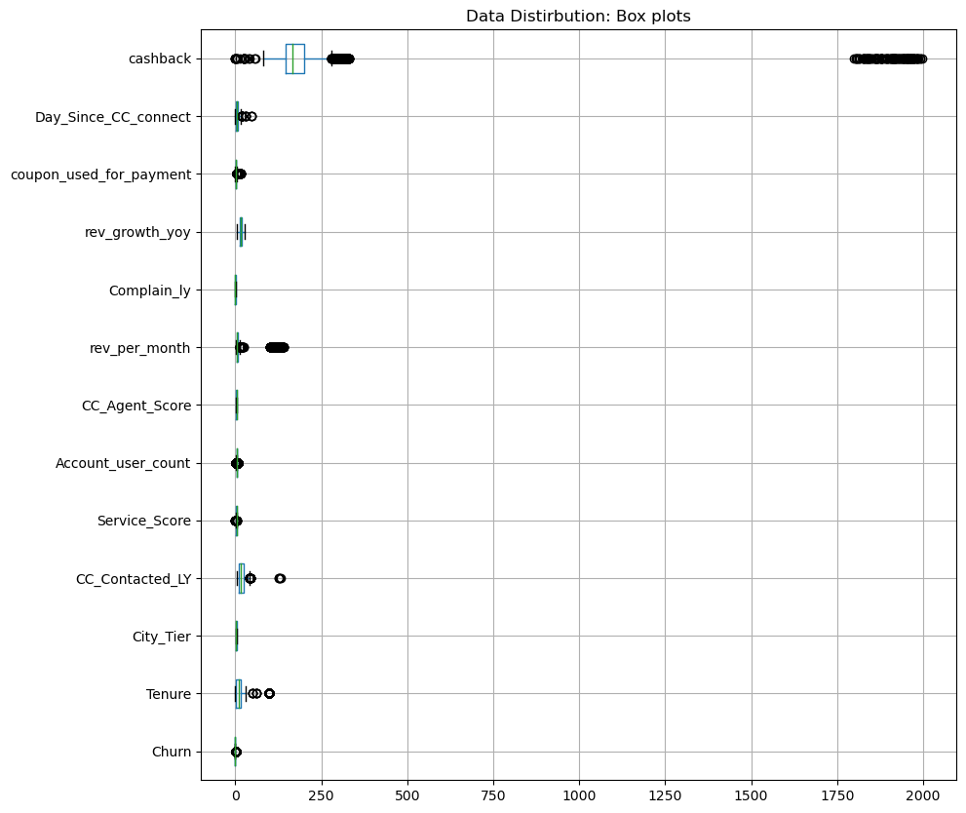

Figure :Boxplot: Numeric feature data distribution

* From this above box-plot we can understand 2 things, one is the data distribution in numeric feature and other thing is extreme values or outliers.
* We could notice that more no. of outlier in the features such as [ ‘cashback’, ‘Day_since_CC_conect’, ‘coupon_used_for_payment’, ’rev_growth_yoy’, ’rev_per_month, ‘Account_user_count’,’ service_score’, ‘CC_contacted_LY’, ‘Tenure’, ‘Churn’].
* We need to treat those outliers, will do it later.

#### **3.A (2) For Categorical Feature:**

* Let’s visualize the dependent variable data distribution.

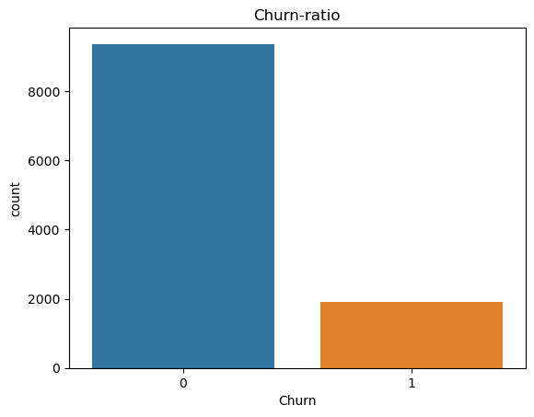

Figure :countplot: Churn

* We could see more than 8K customers are non-churners and nearly 2K customers are in verge of churning.
* Like that we will do visualization for all the categorical features.

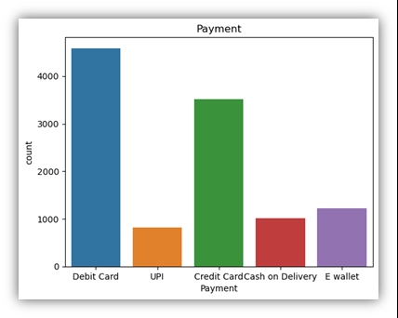

Figure :countplot: Payment method

* More than 4k plus customer have preferred to make payment using debit cards and the next majority of customers preference would be credit cards, which nearly 3.5K.
* We could see very less no.of customer preferred to use UPI payment. And also same no.of people wished to do cash-on-delivery for their payment method.
* We could see 1K plus customers have wished to do E-wallet payment.

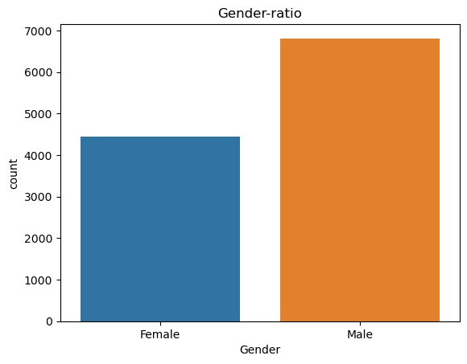

Figure :countplot: Gender ratio

* If we look at the gender ratio distribution, we can notice that male has been present in the data set in more numbers (nearly 7K) than female (nearly 4.5K).
* So, the company has more number of male customers, DTH company can offer some interesting plans on budget to get more no.of female customers.

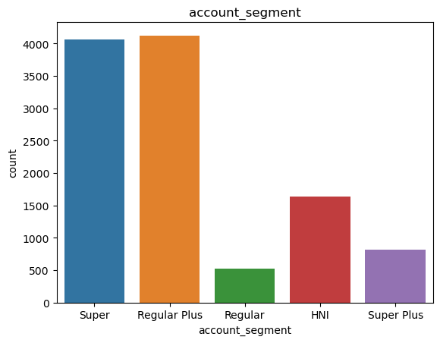

Figure : count-plot: Account segment (Plans)

* From this above plot, we could see that Super & Regular plans are the most selling plans.
* And Regular plans has been sold is very less numbers compared to HNI and Super plus plans.
* This indicates that company decided that more revenue can be generated using the super & regular plus plans. So, they will offer more offers on those plans and captured more customers on this plan.

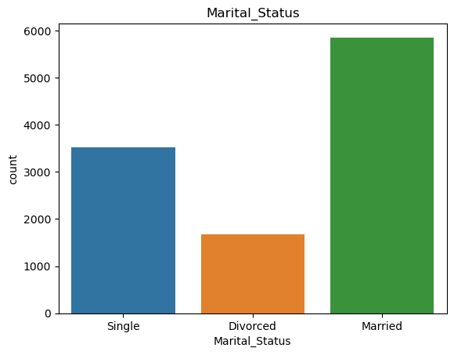

Figure :Count plot: Marital status

* From this marital status plot, we could see that nearly 6K customer was married and around 3.K customer was single.
* And around 2K of the customer are divorced.

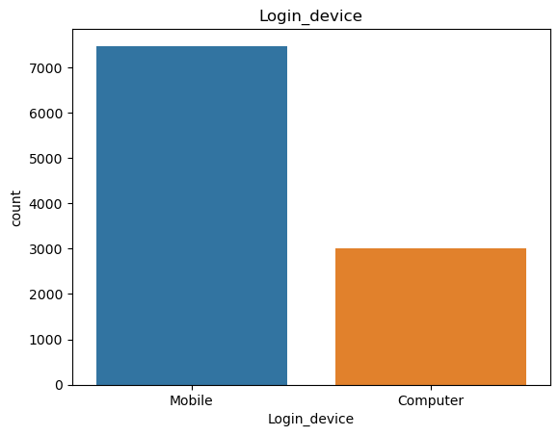

Figure :count plot: Login device

* We could see majority of the customer preferred to login to company portal through mobile.
* And around 3K customers also login through computer.

### **Inferences-Univariate:**

* The city with tire type "1" has the highest number of customers, indicating a high population density in that city type.
* The majority of customers prefer debit and credit cards as their mode of payment.
* There is a higher ratio of male customers compared to female customers.
* On average, customers give a service score of around "3," indicating areas for improvement.
* The "Super+" segment has the highest number of customers, while the "Regular" segment has the fewest customers.
* Most of the customers who avail services are married.
* The preferred device for most customers to access services is mobile.

## **3.B Bivariate analysis (relationship between different variables, correlations):**

* Let’s do the Bi-variate analysis and explore more about this data and try to find reason for churning by visually.

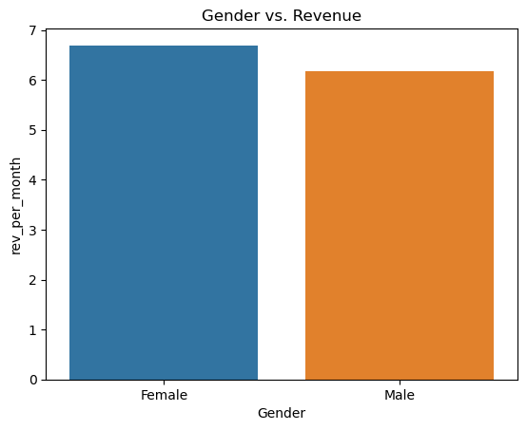

Figure : Bar plot: Revenue per month by gender

* If we interested to know the revenue generation by gender, we can look through the above graph and come to know female have more average revenue generation around 7$ per month more revenue than male which is around 5.9$ per month.
* Even though the male ratio has in more numbers but when we look for the revenue, then female customers take a lead here.

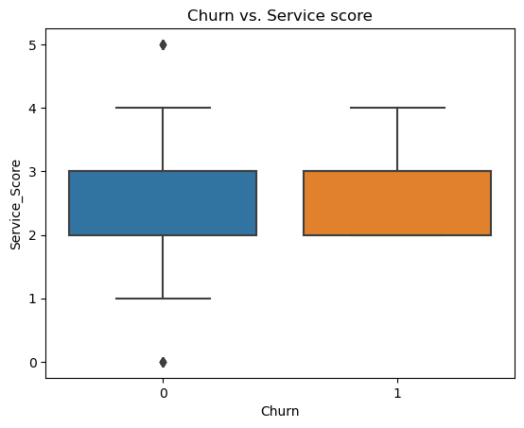

Figure : Bar plot: Churning based on service score

* We have tried to look at how the service of customer impacting the churning.
* By doing this visualization, we come to know that, it doesn’t make such impact in churning both churn and non-churners are both of the median score would be in around 3.

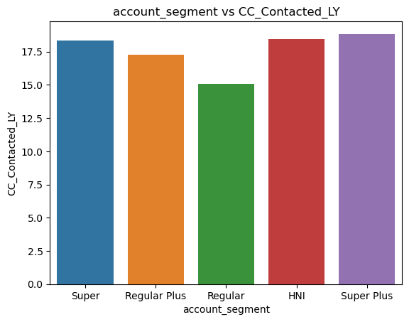

Figure : Customer care contacted last year based on Account segment(plans)

* When we look at the customers based on plan who have contacted the customer care last year.
* We could see that Super plus plan holding customer have been contacted 17 times on average last year.
* Next, we could see that Super and HNI plan holding customer have contacted customer in more or less same number of times.
* And Regular plan holding customers have contacted on average of 15 days in the last year.

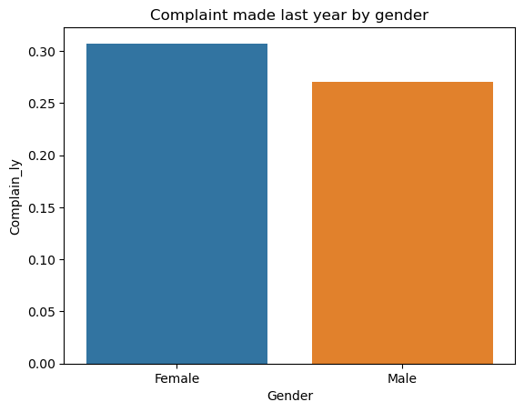

Figure : Bar plot: Complaint made by gender

* From this above plot, we could see female has made on average of 30 complaints in last year whereas male is raising nearly 25 complaints last year.
* This indicates that most of this household things have been handles by females and they will raise complaints if they face any issue while broadcast.

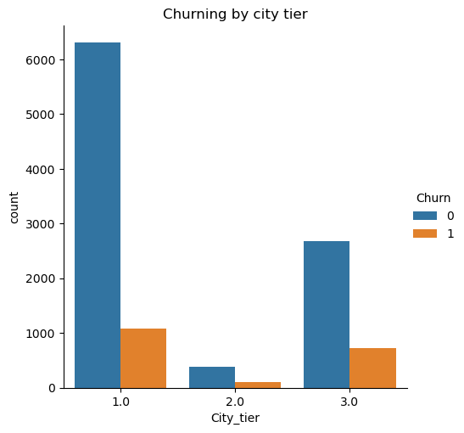

Figure : Churning by city tier

* When we look at the churning by city tier, we could see that a greater number of churning happening on for the city tier 1 then tier 3.
* And very few churners can be noted on tier 2 city.

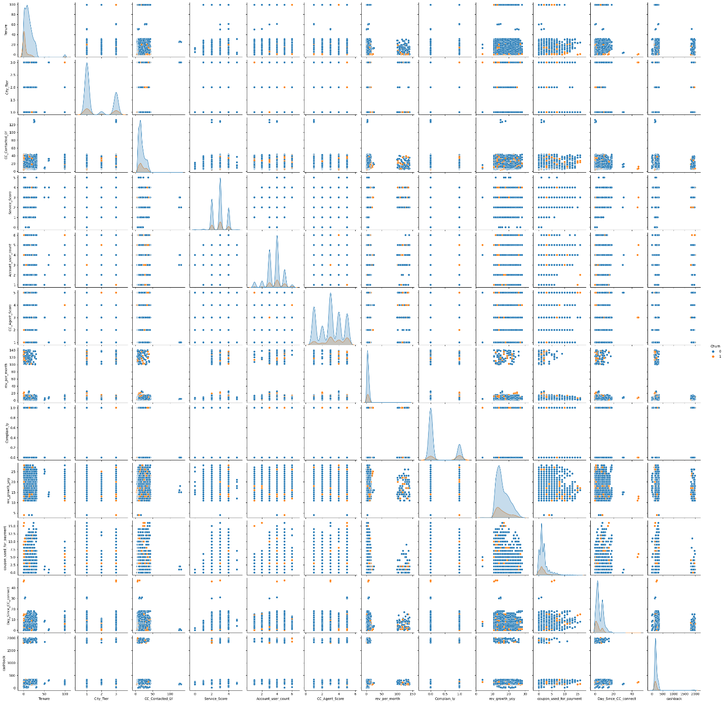

Figure : Pairplot

* The pair-plot shown above indicates that the independent variable are week or poor predictors of target variable as we the density of independent variable overlaps with the density of target variable.

### **Inference: Bi-variate:**

* Based on the above analysis, the following are the summary inferences for the bivariate analysis:
* When considering revenue generation by gender, it is observed that females generate an average of around $7 more revenue per month compared to males, who generate around $5.9 more revenue per month. Thus, despite there being more male customers, females lead in terms of revenue generation.
* The impact of customer service on churn rate was analysed, and it was found that the service score does not have a significant impact on churn. Both churners and non-churners had a median score of around 3, indicating that service quality alone does not strongly influence customer churn.
* Analyzing the frequency of customer care contacts based on the plan held, it was observed that customers with the "Super Plus" plan contacted customer care an average of 17 times in the last year. Customers with the "Super" and "HNI" plans had a similar number of contacts, while customers with the "Regular" plan contacted customer care an average of 15 times in the last year.
* The plot depicting the number of complaints filed in the last year revealed that females filed an average of 30 complaints, while males filed around 25 complaints. This suggests that females tend to handle household matters and are more likely to raise complaints if they encounter any issues with the broadcast.
* When examining churn rates by city tier, it was observed that a higher number of churners were from city tier 1, followed by tier 3. Only a few churners were noted in tier 2 cities.
* The pair-plot analysis indicated that the independent variables are weak or poor predictors of the target variable, as the density of the independent variables overlaps with the density of the target variable.

## **3.B (1) Multi-variate Analysis:**

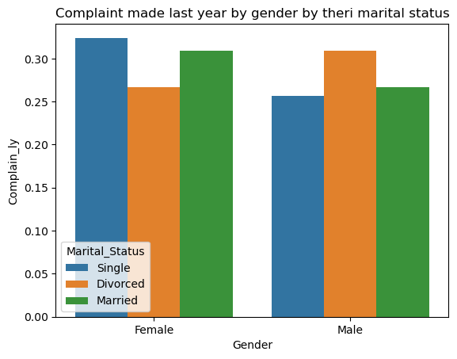

Figure :Gender wise complaints registered based on their marital status

* From this above plot, we could see that a greater number of complaints has been registered by the female, which has marital status as single.
* And secondly the divorced males registered more complaints.
* Among all, we could see less complaints have been registered by single male.

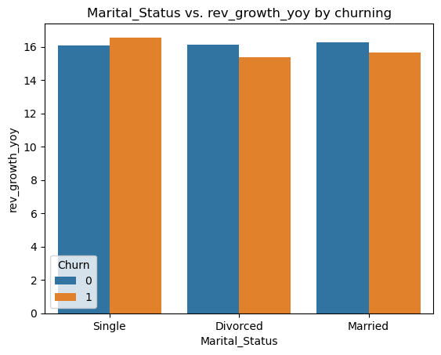

Figure : Churning by marital status with revenue growth yoy

* When we look at the revenue growth by their marital status for churning.
* We can able to see that Singles are generation more revenue yearly and also, they are in the verge of churning.
* Divorced and married customers are generating good revenue over the year but they also tend be in churning.

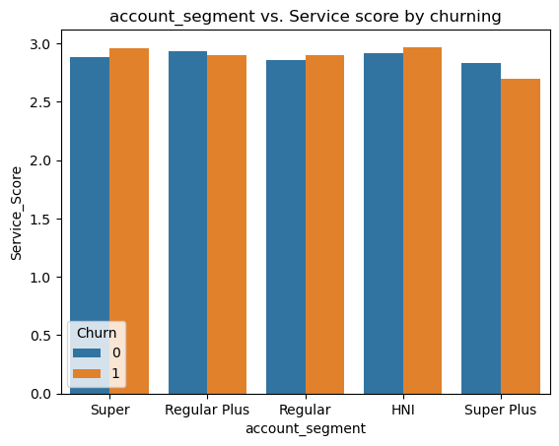

Figure : Service score by account segment with their churning pattern

* We could see that HNI customers have been rated on average service score of 3 but they also fall in verge of churning compared to others.
* And then customer who have chosen their plan as super they also fall in verge of churn.
* We could see a greater number of churns happen for the customer whose plans are super, Regular and HNI.

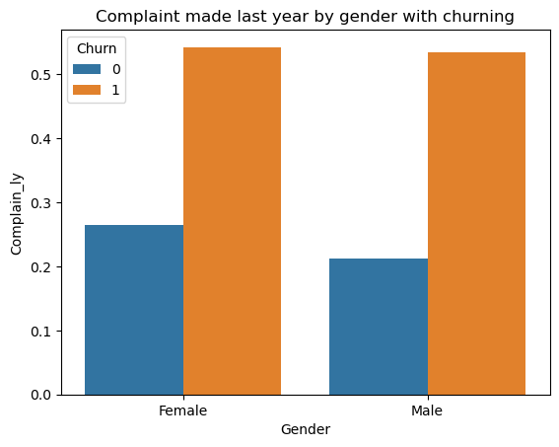

Figure :Complaint’s registered by gender ratio based on churning

* From this plot, we could see that male and female customer are register complaints on average of 5 times will not be fall under churning customer.
* And Gender female are in the greater number of churning compared to male whose average complaints registered would be 3.

### **Inference-Multivariate:**

* The following are the summary inferences for the multivariate analysis:
* The plot indicates that females, particularly those with a single marital status, registered a higher number of complaints. The second highest number of complaints were registered by divorced males. Interestingly, single males had the fewest registered complaints.
* When examining revenue growth based on marital status and churn, it was observed that singles generated the highest revenue annually but were also at a higher risk of churning. Divorced and married customers also generated substantial revenue but had a tendency towards churning.
* HNI customers, despite having an average service score of 3, were also at risk of churning compared to other customer segments. Similarly, customers who had chosen the "Super" plan were also prone to churn.
* The customer segments with the highest churn rates were those who had selected the "Super," "Regular," and "HNI" plans.
* Another plot revealed that customers, both male and female, who registered an average of 5 complaints were less likely to churn. However, females had a higher number of churners compared to males, with an average of 3 registered complaints.

## **3.B (2) Correlation among variables:**

* After addressing bad data and missing values, we conducted a correlation analysis between variables.
* To facilitate the correlation analysis, we converted the variables into integer data types since categorical data types do not appear in the figures shown below.

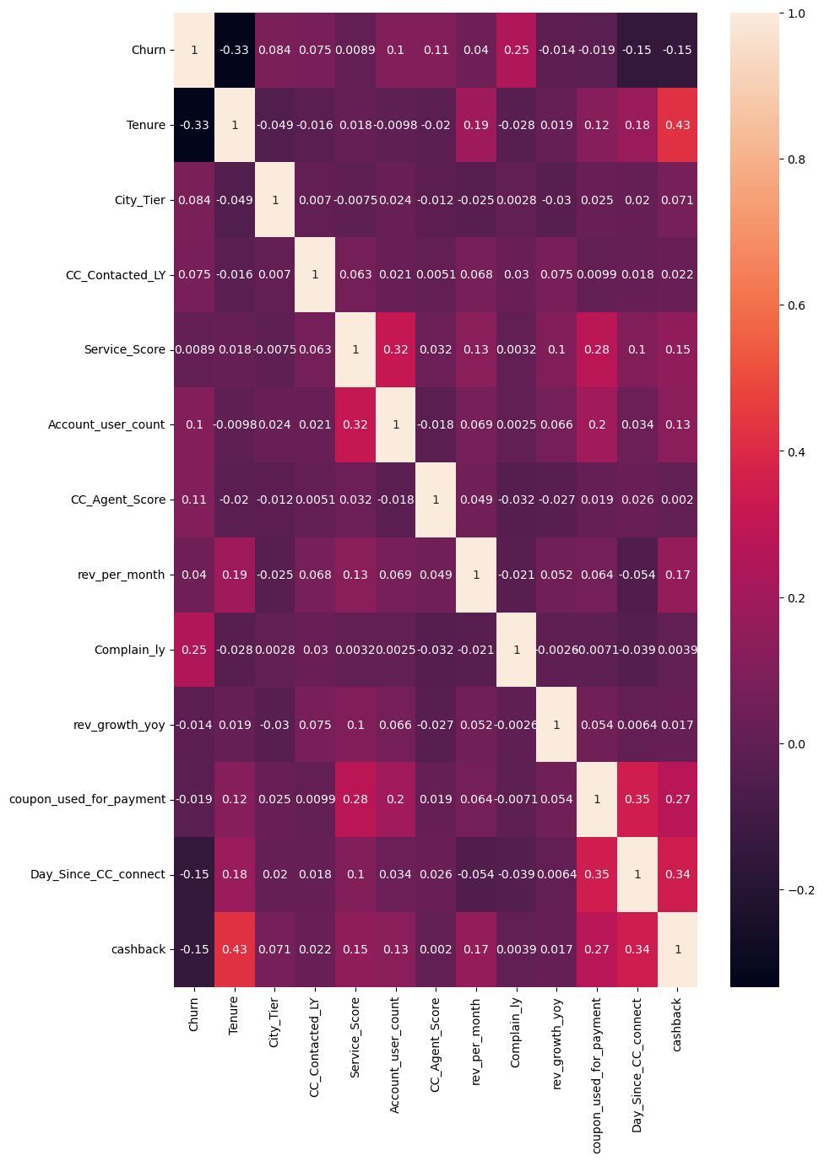

Figure : Correlation map

### **Inference from correlation:**

* Variable “Tenure” shows high co-relation with Churn.
* Variable “Marital Status” shows high co-relation with churn.
* Variable “complain_ly” shows high- correlation with churn.

## **3. (c) Any other business insights:**

1. **Churn Prediction:** Businesses can leverage historical customer data and predictive modelling techniques to identify customers who are at risk of churn. By analyzing various factors such as customer behaviour, engagement, usage patterns, and demographics, predictive models can assign a churn probability score to each customer. This insight enables proactive retention strategies to be implemented for high-risk customers.
2. **Customer Segmentation:** Clustering or segmentation techniques can help categorize customers based on their churn behaviour and characteristics. By understanding the different segments of churners, businesses can tailor retention strategies to address the specific needs and pain points of each group. For example, different approaches may be required to retain high-value customers compared to those who churn due to pricing concerns.
3. **Improving Customer Experience:** Enhancing the overall customer experience is crucial in reducing churn. Businesses should focus on delivering exceptional service, personalized interactions, and efficient problem resolution. Regularly collecting and analyzing customer feedback can provide insights into areas that need improvement and help prioritize efforts to enhance satisfaction and loyalty.
4. **Offer Incentives and Rewards:** Providing incentives and rewards to loyal customers can help reduce churn. Loyalty programs, special offers, discounts, or exclusive benefits can incentivize customers to stay and continue engaging with the business. These incentives should be personalized and aligned with customer preferences to maximize their effectiveness.
5. **Proactive Communication and Engagement:** Regular and targeted communication with customers can help build stronger relationships and reduce churn. Businesses should stay in touch with customers through multiple channels, such as emails, newsletters, social media, or personalized notifications. Proactively reaching out to customers who exhibit early signs of disengagement can help address concerns and re-engage them before they churn.
6. **Customer Retention Campaigns:** Implementing targeted retention campaigns can be effective in reducing churn. These campaigns can include special promotions, upgrade offers, personalized recommendations, or cross-selling opportunities. By focusing on the specific needs and interests of individual customers, businesses can increase their retention rate and foster long-term loyalty.
7. **Data-driven Decision Making:** Utilizing customer data and analytics is crucial in understanding churn drivers and making informed business decisions. By continuously monitoring and analyzing customer behaviour, businesses can identify patterns, trends, and early warning signs of churn. This information can guide strategic initiatives, product/service improvements, and retention efforts.
8. **Customer Feedback and Exit Surveys:** Collecting feedback from churned customers can provide valuable insights into the reasons behind their decision to leave. Conducting exit surveys or interviews can help uncover underlying issues or areas of improvement within the business. This feedback can inform future strategies, product enhancements, and operational changes to reduce churn.

# **4). Model building and interpretation.**

## **4 (a). Build various models (You can choose to build models for either or all of descriptive, predictive or prescriptive purposes)**

* In the upcoming phase of the capstone project, we will proceed with model building after conducting exploratory data analysis (EDA) and data cleaning.
* This will be followed by model tuning and evaluating the performance using various metrics such as Accuracy, F1 Score, Recall, Precision, ROC curve, AUC score, Confusion matrix, and classification report.
* Our goal is to select a model that avoids both underfitting and overfitting while achieving the highest possible accuracy.

**Splitting Data into Train and Test Dataset: -**

* Following the commonly accepted practice in the market, we have split the data into a training dataset and a testing dataset using a ratio of 70:30.
* We will proceed with building various models using the training dataset and assess their accuracy by testing them on the independent testing dataset.

**Below is the shape of Train and Test dataset:**

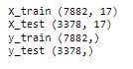

Figure :Shape of Training and Test data set

**Steps performed before Model Building: -**

* Treating null values
* Outlier Treatment
* Treating anomaly
* Scaling data
* Replacing object type categorical variable with integer types

## 

## **4. (B). Interpretation of the most optimum model and its implication on the business**

Table :Comparison Across Various Models

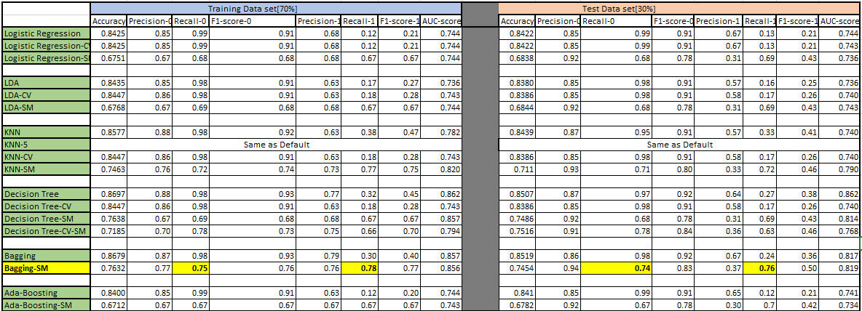

**Indicators/symbols for above tabular data:**

* CV: - indicates scores for model built on best params obtained from GridSearchCV
* with model name as prefix.
* SM: - indicates scores for model built on balanced dataset with model name as

prefix.

* KNN-5: - Indicates KNN model built with N_neighbors as “5”

**4.(C) Inferences on final model:**

* Recall is a metric that measures the proportion of true positives that are correctly identified by the model. In the context of churn prediction, recall would measure the proportion of customers who actually churn that are correctly identified by the model as being likely to churn.
* Recall is important because it helps to ensure that the model does not miss any potential churners. If a model has low recall, it may not identify all of the customers who are at risk of churning. This could lead to the business losing customers that it could have retained
* Based on the evaluation metric score table, the best model is Bagging which was built on balanced data set. It has the high recall values on both the training and test data sets.
* The model has an accuracy score of 0.76 on the training dataset and 0.74 on the testing dataset. This indicates that the model is generalizable and can be used to make predictions on new data.
* The model has a high recall score for both the training and testing datasets. This means that the model is good at identifying true positives, or customers who are likely to churn.
* The model has a low precision score for the testing dataset. This means that the model is more likely to predict that a customer will churn, even if they are not actually likely to churn.
* The f1-score for the testing dataset is 0.77. This is a good score, and indicates that the model is doing a good job of balancing precision and recall.
* Overall, the bagging model appears to be well-performing and generalizable. However, the low precision score for the testing dataset indicates that the model may be overfitting the training dataset. This could be due to the fact that the data is imbalanced, or that the model is too complex. To improve the performance of the model, you could try:
* Balancing the data. This will help to reduce the impact of overfitting.
* Simplifying the model. This will make it less likely to overfit the training dataset.
* Using a different model. There are many different machine learning models that can be used for churn prediction. You could try experimenting with different models to see if you can find one that performs better than the bagging model.
* Here are some additional insights:
* The model is more likely to correctly identify customers who are likely to churn (high recall score).
* The model is less likely to correctly identify customers who are not likely to churn (low precision score).
* The model is generalizable and can be used to make predictions on new data (high accuracy score on testing dataset).
* The model may be overfitting the training dataset (low precision score on testing dataset).

**Significant variables based on Bagging model:**

* Login_device
* coupon_used_for_payment
* CC_Agent_Score
* Marital_Status
* Complain_ly

**Recommendations based on significant features:**

* Login_device: If the customer is more likely to login using a mobile device, you can recommend that they use the mobile app to make payments. This will make it easier for them to pay their bills and track their spending.
* Coupon_used_for_payment: If the customer is more likely to use coupons for payment, you can recommend that they sign up for the company's email list or loyalty program. This will help them to stay up-to-date on the latest coupons and discounts.
* CC_Agent_Score: If the customer is more likely to give a high CC_Agent_Score, you can recommend that they contact customer service if they have any problems. This will help them to get their issues resolved quickly and easily.
* Marital_Status: If the customer is married, you can recommend that they add their spouse as an authorized user on their account. This will give their spouse access to the account and make it easier for them to make payments.
* Complain_ly: If the customer has filed a complaint in the past, you can recommend that they contact customer service to see if there is anything that can be done to resolve the issue. This will help them to get their issue resolved and prevent them from churning.

**Four Stages of Churn Management**



* Introduce pre-defined customer segmentation and according to customers needs and usage.
* Acquiring customers through different strategies

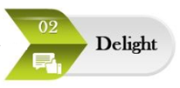

* Delighting customers in order to increase customers loyalty as compared to competitors.

Machine generated alternative text:
-03 
Prewnt 

* Preventing Customers from attrition through analyzing various churn signals and triggers

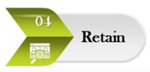

* Focus on saving customers from leaving the firm through several campaigns

# **5.Recommendations:**

* Business can introduce referral drive for existing customers to acquire new customers.
* Business can be in joint with other life style vendors to provide vouchers to the new as well existing loyal customers.
* Business can internally bifurcate its customers based on spending pattern into deal seeker, tariff optimizer etc. and can have different acquisition strategy for each set of customers.
* Offering free cloud storage to loyal customers.
* Customized email response to priority customers basis segmentation for better customer interaction.
* Specialized team of customer service for Top notch customers to avoid waiting time and better customer experience and interaction.
* Understanding customers profile and sending small token of gift on special days.
* Thanking customers with hand written notes on invoices will create a good will factor.
* Follow-up in customers issues and taking regular feedbacks on the same.
* Conducting satisfaction survey to understand change in customers behavior.
* Business need to make sure that all complaints and queries raised are resolve on time.
* Business can promote using their own e-wallet as payment option by giving certain discount over the bill.
* Business needs to come up with subsidized offers for customers who are single as they show high trend to churn.
* Business need to introduce all-in-one family plan with extra services, it will make accessibility easier for customers.
* Business needs to increase in visibility in Tier-2 city for better customer acquisition.
* Business can promote payment via standing instruction in bank account or UPI which can be hassle free and safe for customers.
* Customers can divide into 4 sets as shown in figure.

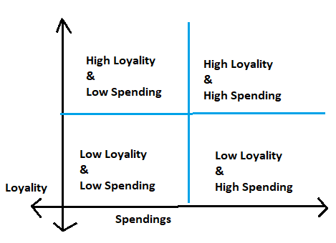

Figure :Customer segments

* And at times business needs to take harsh decision of letting go the customers with “low on loyalty and Low on spending”.
* Customers under set of “High Loyalty & High Spending” can be retained by delighting them with various offers.
* Customers under “High Loyalty & Low Spending” can be offered with bundled family floater plan to increase on their spending’s.
* The 4th quadrant can be the major area of observation for business where in customers are “low on loyalty but high on spending’s”, they can be retained by increasing the service level index and with proper follow-up on running offers and subscriptions.